**Intramuscular (IM) Injection Administration Sites Tip Sheet**

# Contents:

1. Selecting an appropriate IM injection site
2. Ventrogluteal Muscle
   1. To locate site using “V” method
   2. To locate site using “G” method
3. Deltoid Muscle
4. Vastus Lateralis Muscle
5. Z-Track method

# Selecting an appropriate IM injection site:

When selecting an IM site, determine that the site is:

* free of pain
* infection
* necrosis
* bruising
* abrasions.

Also consider the location of underlying bones, nerves, and blood vessels and the volume of medication that you will administer. If a medication is not injected correctly into a muscle, complications can arise such as abscess, hematoma, ecchymosis, pain, and vascular and nerve injury.

**Note:** Dorsogluteal is not recommended as an injection site because of the sciatic nerve location.

## 

## Ventrogluteal muscle:

The ventrogluteal muscle is the preferred and safest IM injection site for all adults, children, and infants, especially for medications that have larger volumes and are more viscous and irritating.

## 

## To locate site using “V” method-

1. Assist patient into supine or lateral position with knee and hip flexed to relax muscle.
2. Use your right hand for left hip and left hand for right hip and place your palm on the greater trochanter of the hip with wrist perpendicular to femur.
3. Then move your thumb toward the patient’s groin and your index finger toward the anterior superior iliac spine.
4. Extend or open your middle finger back along the iliac crest toward the patient’s buttock.
5. The index finger, middle finger, and iliac crest form a V-shaped triangle, with the injection site in the center of the triangle.

## To locate site using “G” method-

1. With a patient in the side-lying position, you reference three bone prominences and draw imaginary lines between the ends of the bones.
2. Imagine lines drawn from the patient’s greater trochanter to the iliac crest, and then to the anterosuperior iliac spine, and from the greater trochanter to the anterosuperior iliac spine. Thus, a triangle is created by the imaginary lines.
3. After that, draw median lines from every single corner of triangle to the opposite side.
4. The convergence point of the three median lines is the center for the triangle, the needle entry point for IM injections.

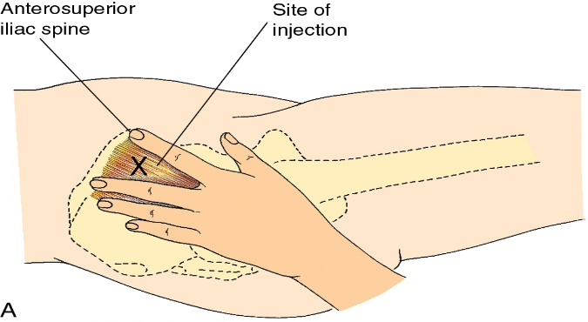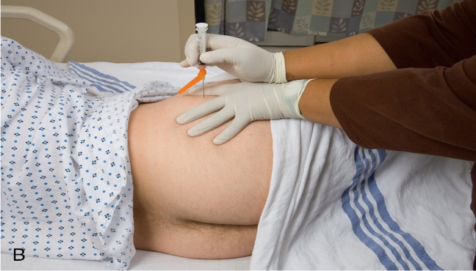

# Deltoid muscle:

The deltoid muscle is easily accessible, but the muscle is not well developed in many adults. There is potential for injury because the axillary, radial, brachial, and ulnar nerves and the brachial artery lie within the upper arm under the triceps and along the humerus.

Locate the deltoid muscle by fully exposing the patient’s upper arm and shoulder and asking the patient to relax the arm at the side or by supporting the patient’s arm and flexing the elbow. Do not roll up any tight-fitting sleeve.

Palpate the lower edge of the acromion process, which forms the base of a triangle in line with the midpoint of the lateral aspect of the upper arm. The injection site is three finger widths below the acromion process.

**Note:** Use this site for small medication volumes (2 mL or less).

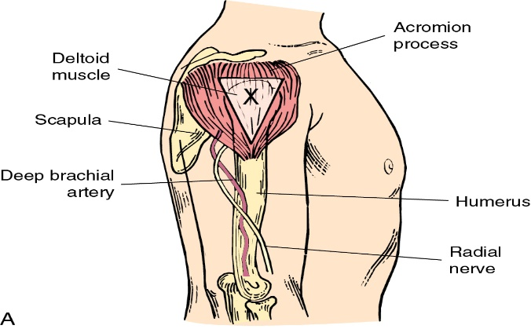 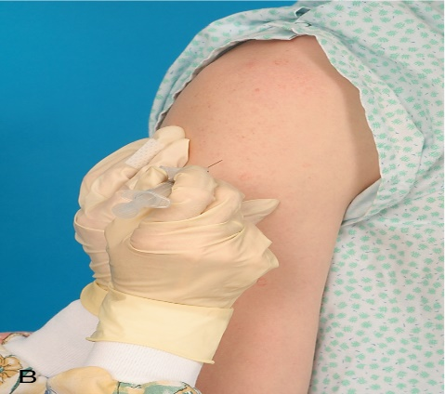

# Vastus lateralis muscle:

The vastus lateralis muscle is another injection site used in adults and is an alternate site for administration of medication or biologics (e.g., immunizations) to infants, toddlers, and children.

It extends in an adult from a hand breadth above the knee to a hand breadth below the greater trochanter of the femur. Use the middle third of the muscle for injection. The width of the muscle usually extends from the midline of the thigh to the midline of the outer side of the thigh.

With young children or frail patients, it helps to grasp the body of the muscle during injection to be sure that the medication is deposited in muscle tissue.

To help relax the muscle, ask the patient to lie flat with the knee slightly flexed and foot externally rotated or to assume a sitting position.

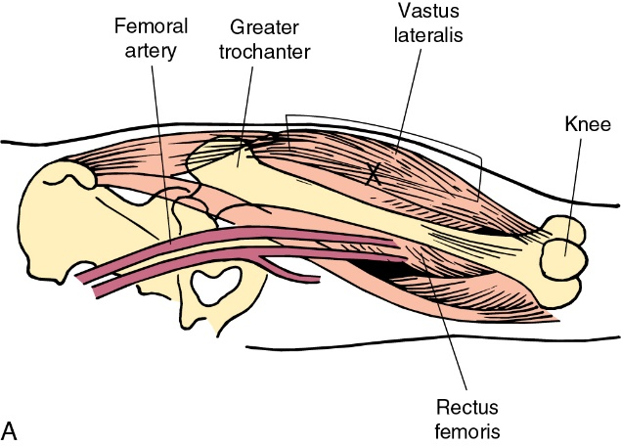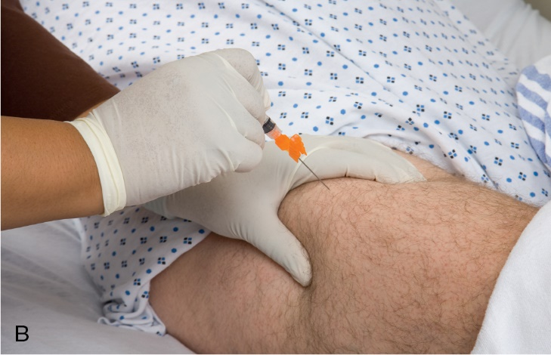

# Z-Track Method:

The Z -track method, a technique for pulling the skin during an injection, is recommended for IM injections (Ayinde et al., 2021). It prevents leakage of medication into subcutaneous tissues, seals medication in the muscle, and minimizes irritation.

**To use the Z -track method** (most commonly used with ventrogluteal muscle injections)**-**

1. Pull the overlying skin and subcutaneous tissues approximately 2.5 to 3.5 cm (1–1½ inches) laterally to the side with the ulnar side of the nondominant hand.
2. Hold the skin in this position until you have administered the injection.
3. Inject the needle deeply into the muscle, aspirate for blood return, and then inject the medication slowly for 10 seconds.

**EXCEPTION:** To reduce injection site discomfort when administering vaccines or toxoids, the CDC (2022) guidelines state that there is no longer a need to aspirate after the needle is injected. Keep the needle inserted for 10 seconds to allow the medication to disperse evenly. Release the skin after withdrawing the needle. This leaves a zigzag path that seals the needle track wherever tissue planes slide across one another. The medication is sealed in the muscle tissue.

The above information has been retrieved from Clinical Key: Click the following link to review the complete chapter: [Parenteral medications - ClinicalKey for Nursing](https://www.clinicalkey.com/nursing/#!/content/book/3-s2.0-B9780443107184000314?scrollTo=%23hl0003426).

**References:**

Perry, A. G., LaPlante, N., Ostendorf, W. R., & Potter, P. A. (2025). Parenteral medications. In *Clinical Nursing Skills and Techniques* (11th ed., pp. 659–716). essay, Elsevier.